Module 2: Custom Columns, Pivot Table and Master Data
1. Created Duration Details sheet using Customer_ID, Checkin_Date, Checkout_Date and Duration
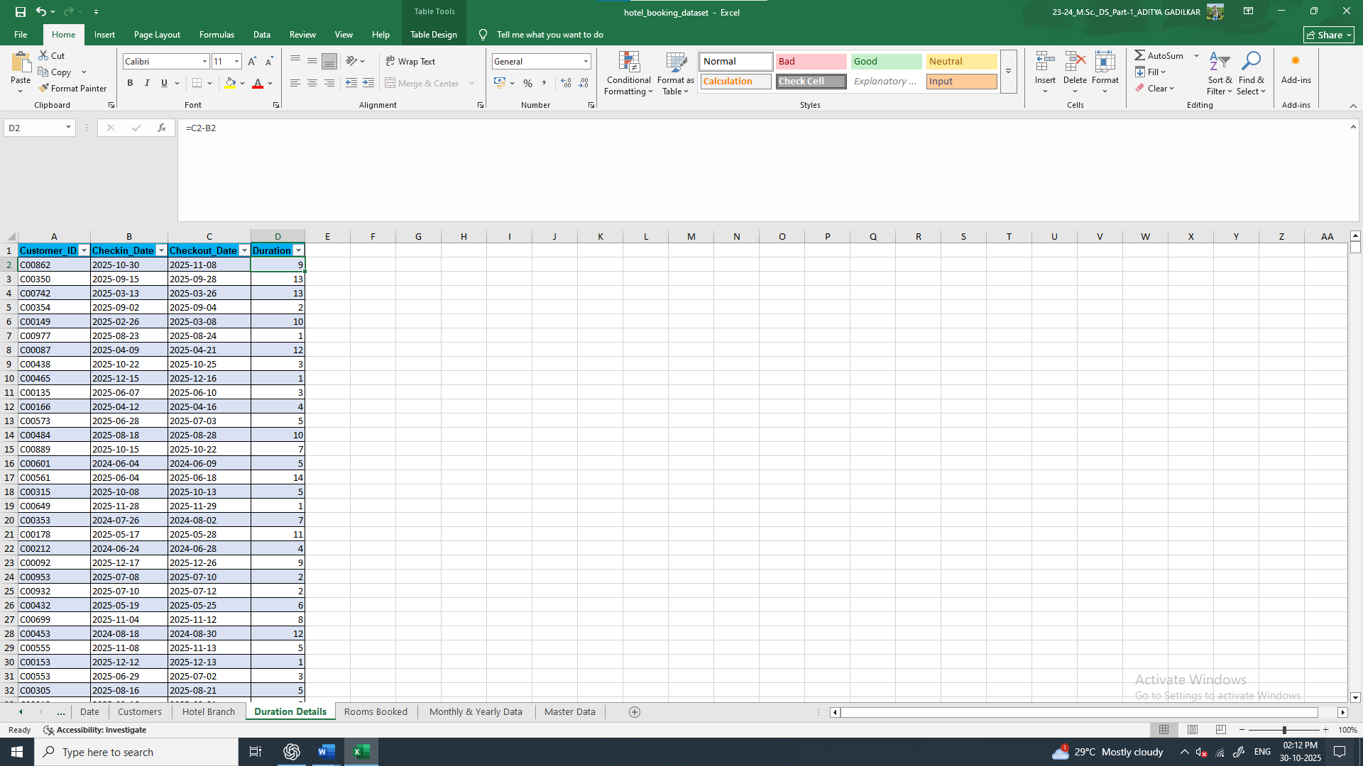

2. Created Stay_Date column using Custom Column in the Power Query Editor
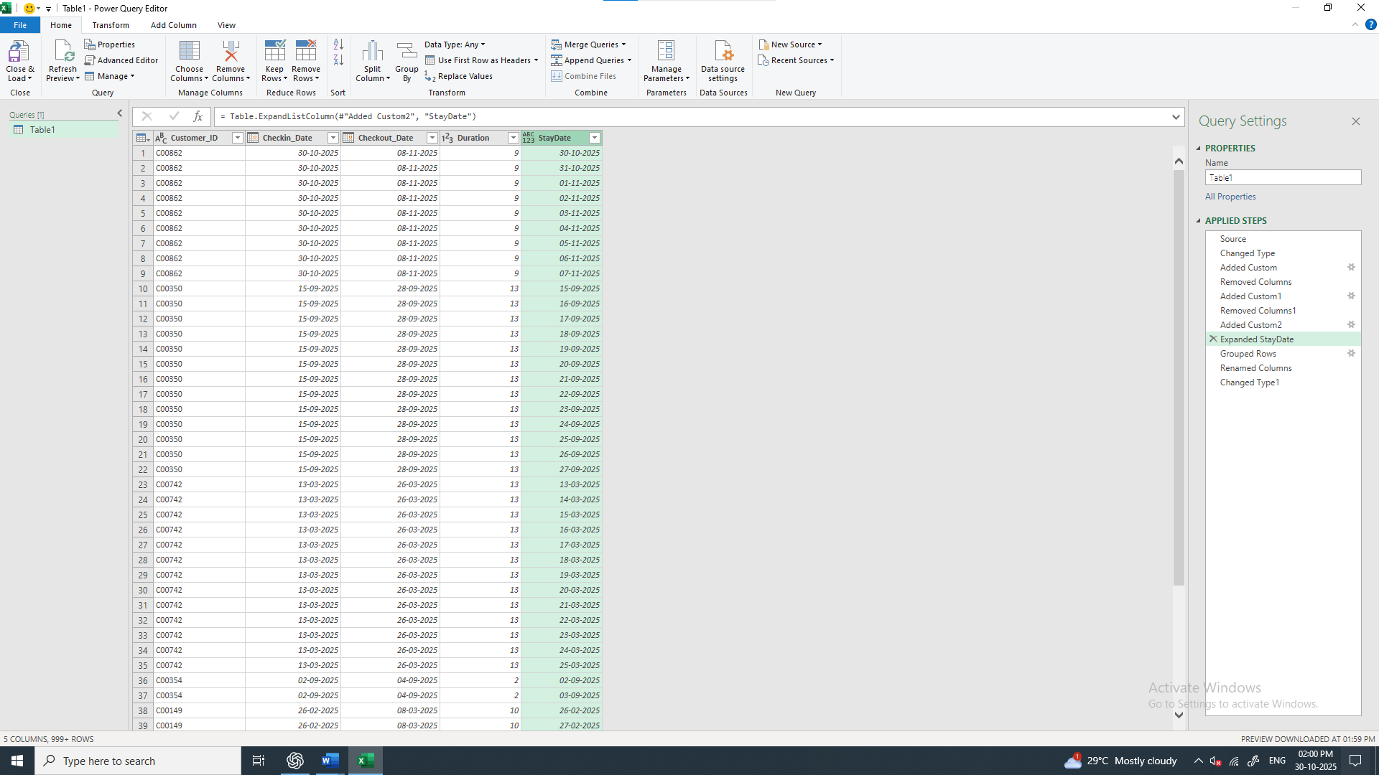
3. Create the Rooms_Booked column using the Group By function in the Power Query Editor
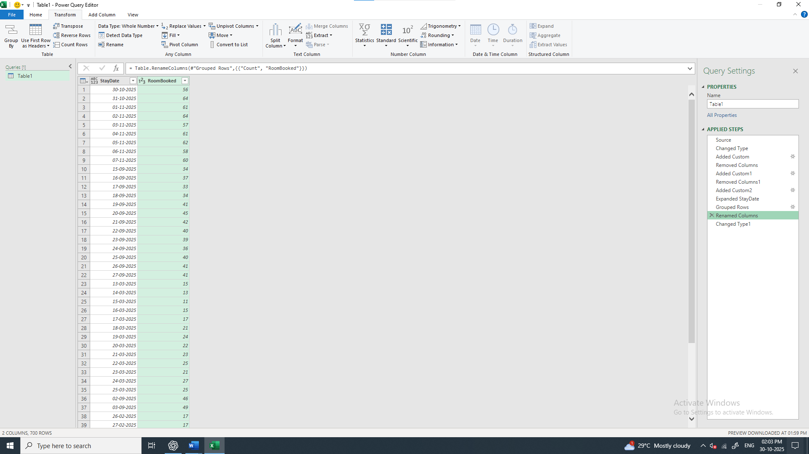

4. Changed the data type of Stay_Date column from Text to Date
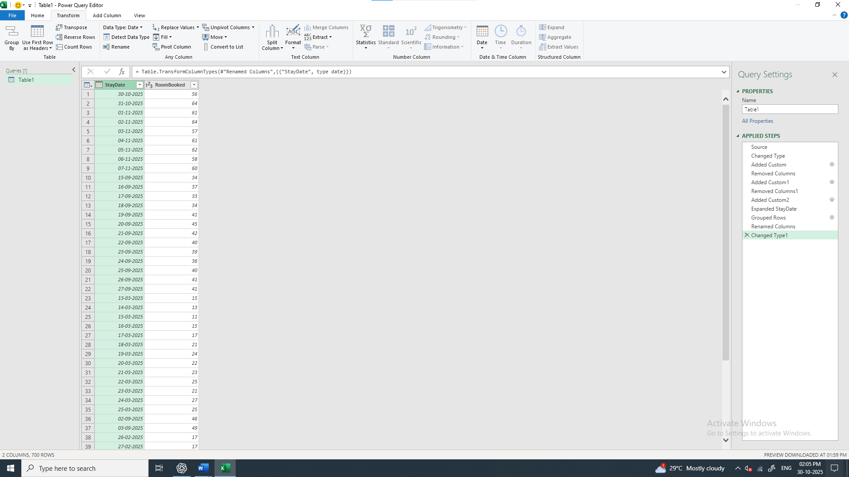

5. Created Pivot Table using the Stay_Date and Rooms_Booked Columns from the Rooms Booked sheet to fetch the Yealy & Monthly Bookings Data
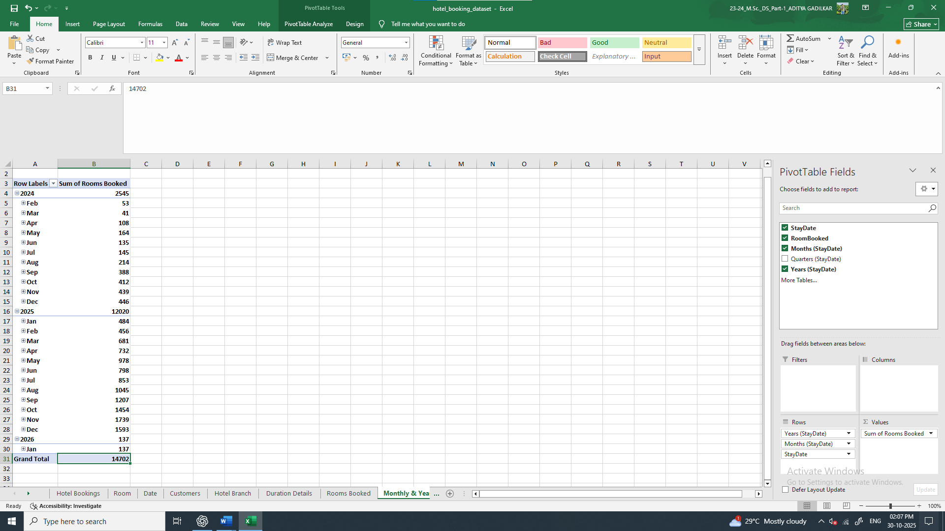

6. Created the Master Data sheet with Month, Day_Count, Rooms_Avalable, Rooms_Sold and Occupancy_% columns
